Develop Coding: assignment

Name: Dondre Tyrell

Website name: TPKvision

Q1.

The purpose of using IT is to develop a website. This is a business website targeted at customers of ‘TPKvision’. I will plan the project by using a Trello board, this is useful because it gives me a reference point for all the different parts of the project, I can add and take away from the project, as well as visually edit as I have new ideas throughout the project. IT will be used to achieve the appropriate outcomes by affording me the appropriate facilities to complete the assignment.

Q2.

In order to help with the project, I utilised software such as VS code, this will help me to script the code. I find it more helpful than platforms such as ‘note++’ because it organises the project well and makes files easily accessible, its also noted that I can install popular such as Pylance, live server and code runner to get the best out of VS code. I will also be utilising basic functionality software such as Microsoft Word to complete assignment elements. A method of research I used to gain extra knowledge throughout the project was Stack overflow this allowed me to search for information about coding that I needed for specific circumstances. I also made the most of services such as YouTube for in dept recaps and google for the quick queries. To complete the task, I will need to demonstrate good time management, I hope to show this with the Trello board. Another resource I will be using to help me finish the task is GitHub.

Q3.

GDPR and copyright laws, as outlined in the Data Protection Act 2018[1], highlights the necessary practices of safeguarding the information of the client and the business, as well as the handling of the information both held and received on the website. It is important to adhere to GDPR in order to safeguard the website from litigation both internal and external.

Q4.

As mentioned, I decided to use VS code as the main coding software to help me complete the assignment. In review I would say that VS code was a great software for completing the assignment, it allowed me to store and access files securely and safety, whilst also displaying each file throughout the process for coding convenience. VS code also has many features that are not on other platforms such as colour coding, auto complete, word wrap, and a variety of extensions built by external coders to make the coding process far more enjoyable. There are very few drawbacks to VS code, notwithstanding the fact that this is a light version of the main product, virtual studio, as such all the features are lighter that usual, for much larger projects it is probably better to use other products.

During the coding assignment I used a TRELLO board as a way of Improving on my personal productivity, I mapped the progress of my coding by uploading the progress to the Trello as I went along, making sure to note additions that I made, as well as using the Kanban techniques as a way of reviewing my progress.

Q5.

I overcame several accessibility issues throughout the project. Earlier on in the project I was flicking back and forth to test the code in the web browser, I soon downloaded the Live Server extension to check the code without having to flick between pages it also gives live updates as I saved my progress, so there was no need to constantly refresh the screen. Another accessibility issue I had was uploading file types such as GIF, instead I used JPG for the image file type in the code because it is easily transferable between devices and takes up a low amount of storage. I chose to use HTML and CSS filetype to store the code of the webpages because the languages are smooth and efficient, it draws a clear divide between sections of the code to make it not only accessible to the coder, but also to people looking to make adaptations to the code once it has been complete, including the potential client. With the client in mind, a way that I overcame accessibility issues in my code was to use: alt = “ ” to label, on my images in order to make a image noticeable in the instance that it wasn’t showing up in a particular browser.

Q6.

Other areas of efficiency throughout the project were using things such as shortcuts in VS Code in order to save time on filling out the codes. In addition to that, I made good used of extensions in vs code such as live server, which meant I didn’t have to flick between screens whiles checking the code, this was made even more efficient by using multiple monitors. Lastly, I found it productive to take regular screen breaks and wear a pair of bluescreen glasses to stop over-exertion during periods of long coding.

Q7.

The final version of the website contains three separate pages, the ‘Home’ page; named index in the code, the ‘about’ page, the ‘contact’ page and the ‘services’ page

Page1 (index) sets out the home page of the clients’ website – this page contains a header, two content sections in the body and a footer. The content sections describe the overall business

Page2 (about) describes the progress of the clients’ business – this page contains two stacked images with headers describing the past and future of the business, complete with a navigation bar and a footer

Page 3 (contact) contains the contact information of the clients’ business contains a single image with description of how to contact the business, this page is also complete with a header, footer and a navigation bar

Page4 (services) describes the services, products and facilities offered by the website, it sets out what the customers might expect if they were to engage with the business by laying four images evenly spaced across the page, with a header and paragraph above them in the body. This page comes complete with a header and footer.

One of the major strengths of this website is its pragmatism, it shows the information that I intended it to, with quite straight forward and efficient coding. Of course, a drawback of pragmatism is that there can be a lack of depth, which causes the website to not be visually appealing as it otherwise could be, however with future knowledge and given more freedom of time the code could be made dense with all manner of capabilities. Another strength lay in the variety of layouts of amongst the pages, it allows the website to seem quite dynamic, this is an attempt to keep the attention of the clients

Q8.

Screenshots of website homepage in 2 different browsers

* <https://dond45.github.io/TPKvision/>

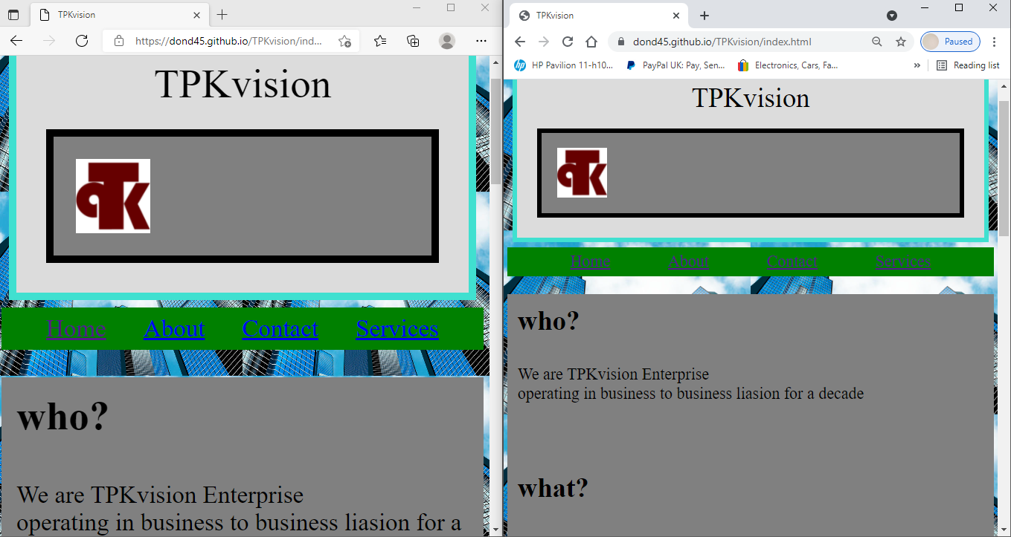

Above is a screenshot of the index page of ‘TPKvision’ working in two different browsers – Microsoft edge (Left) and google chrome (Right).

1. https://www.gov.uk/data-protection